Technical Design Document

Project name: **Skylines**

Developed by: *Vamsi Damisetty*

**Introduction:**

Skylines is created to meet the needs of online flight reservation system, with functionalities:

* Book a Flight
* Check Bookings
* Cancel Reservations

**Functional Requirements:**

**Login/Register:**

A user will be required to log in into the application in order to book tickets. If he/she has no account, they have to register by providing their names, their contact number and other few details.

**Search Flight:**

On providing the required boarding and arrival details user can fetch the details of the flight. After that he/she may proceed for Reservation.

**Flight Reservation:**

A user will be able to create a new Reservation by choosing a flight and providing the details of passenger. After filling all the conformations user is all set for payment.

**Make Payment:**

User can enter the card details but this is dummy payment which is not connected to any bank.

**View Bookings:**

By Clicking on check reservation user may see all the reservations made and now able to cancel the reservation by choice.

**Cancel Booking:**

After clicking on “Cancel Booking” button, a user will receive a confirmation about cancellation of the selected reservation.

**Overall Architecture Diagram:**

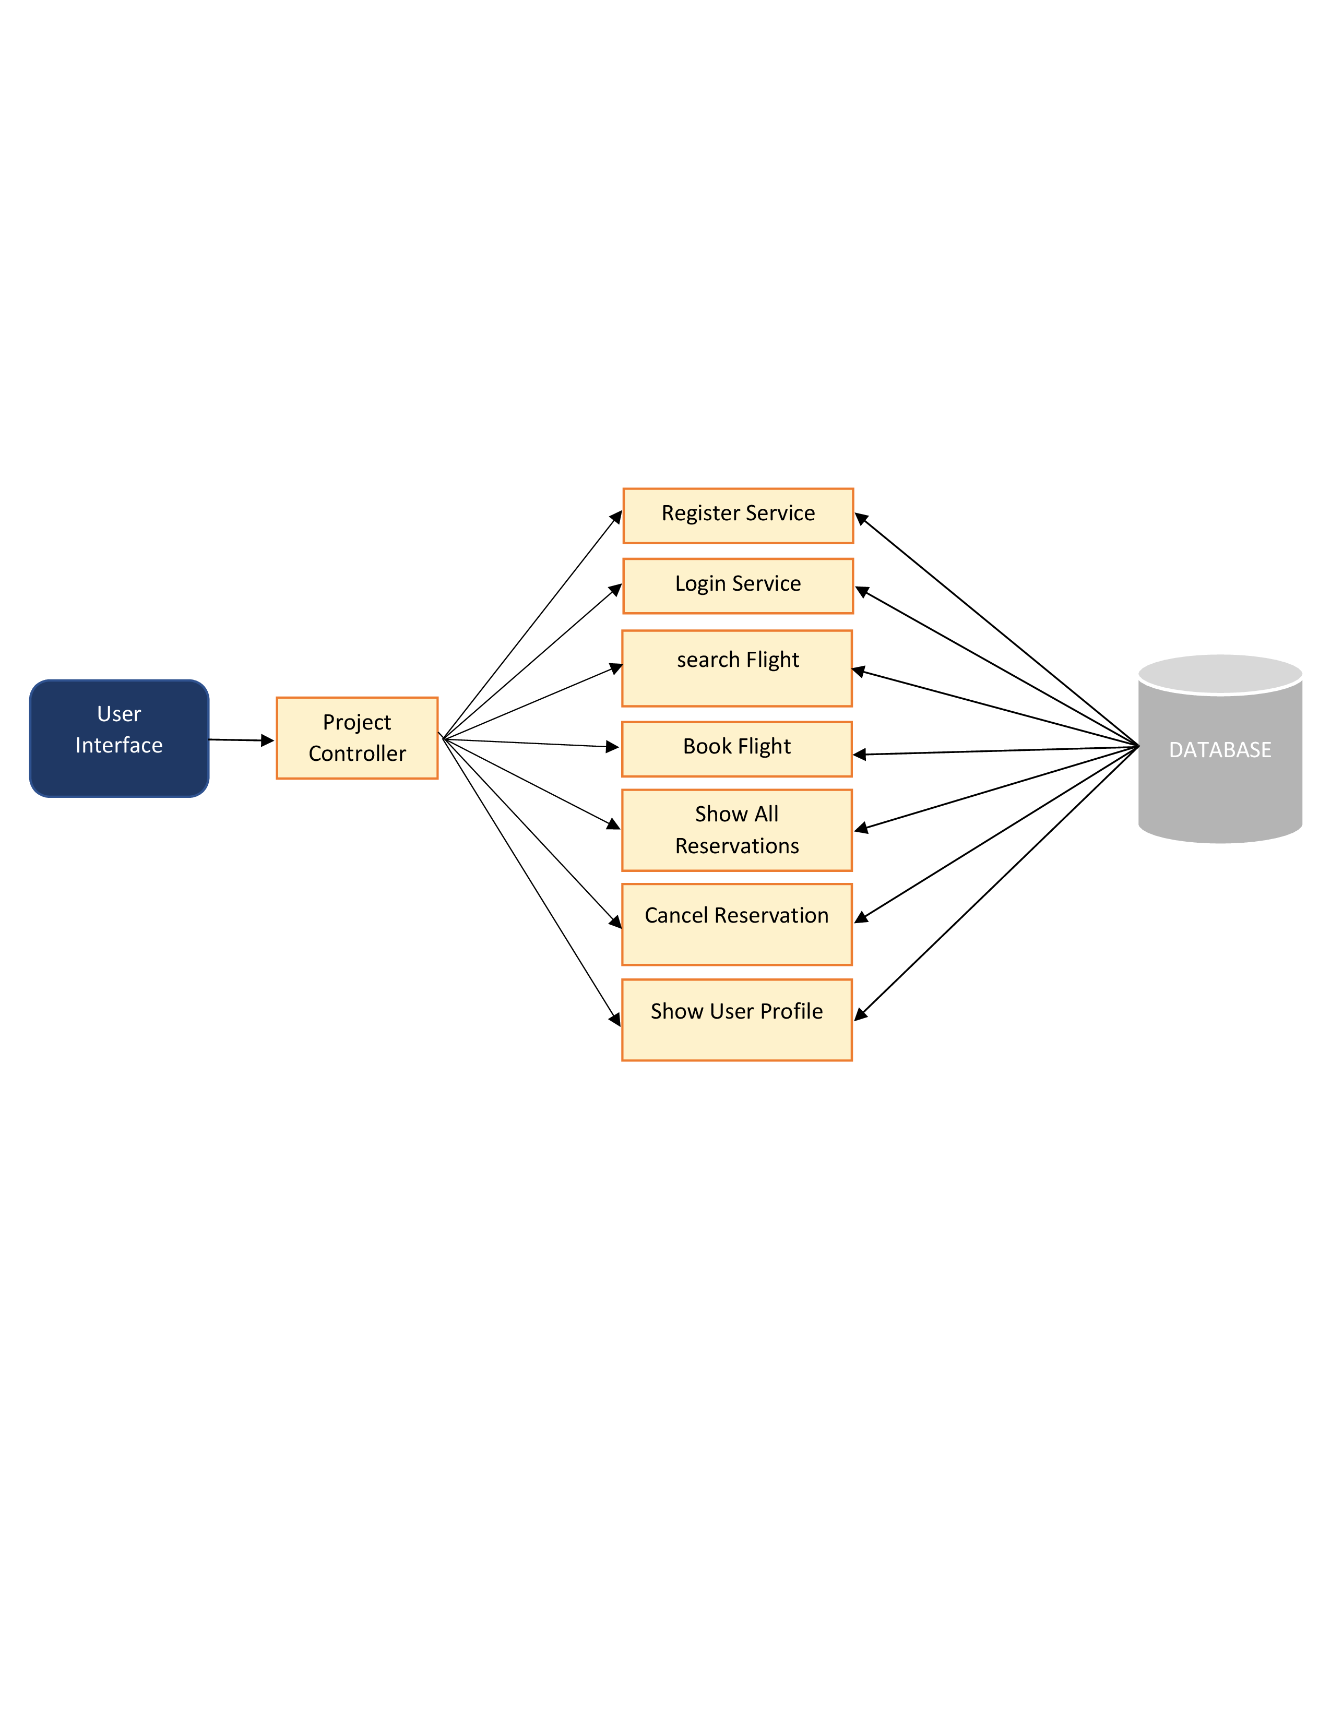

**Overall Entity Relationship Diagram:**

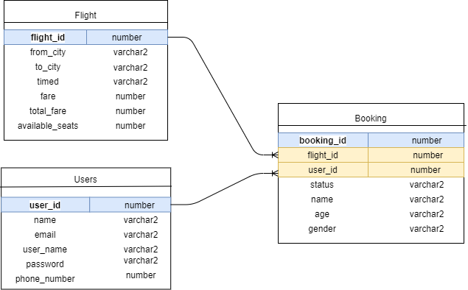

**Class Diagram**

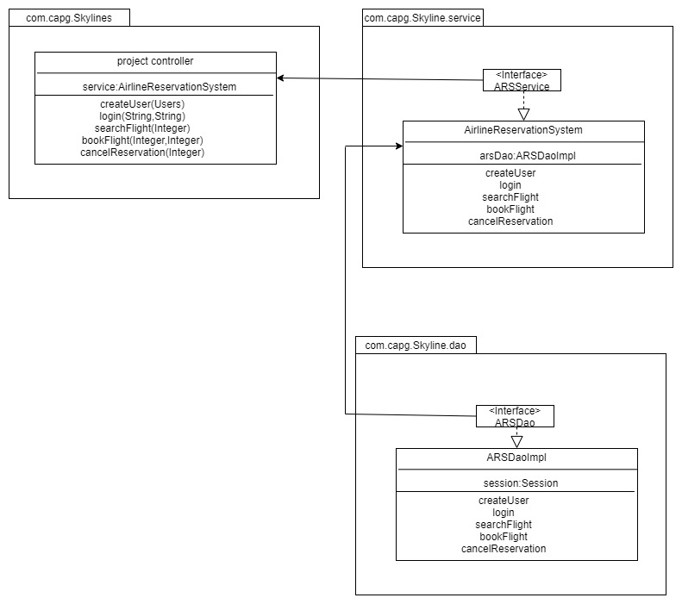

**Activity Diagrams**

**Login:**

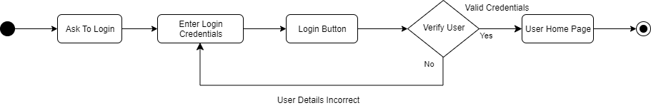

**Registration:**

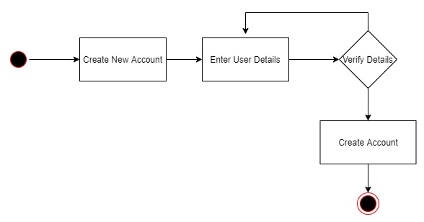

**Search and Book:**

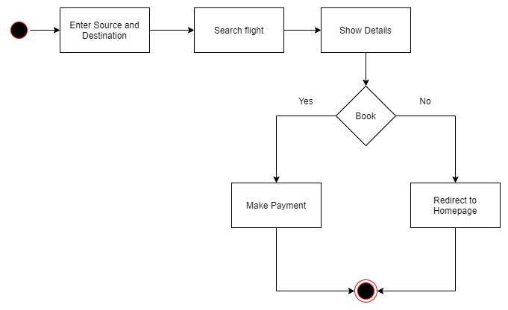

**Cancel Reservation:**

